2012 PRIMARY OLYMPIADS
NORTHERN PROVINCE
- Evaluate 11001_{two} + 101_{two}

- Mr. Bwalya has enough food to last his 10 animals for 18 days. How many days would the same amount of last for 12 animals?

- Given that y = 10, and x = 4, evaluate 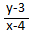

- How many significant figures are there in the number 6 000 000?

- Two sets A and B are disjoint. What is A ∩ B?

- ABC is a straight line as shown below. Find the size of angle x

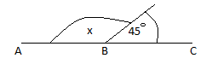

- Evaluate 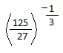

- 14 – x = 16, x is called

- Find the area of the square in m² with length 0.02m

- Find the square root of 81

- 20% of a number is 60. Find the number.

- Write down the mathematical statement shown by the number line below

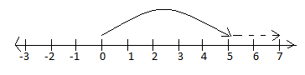

- The circumference of the circle is 154cm. calculate its diameter.

